STRIPES

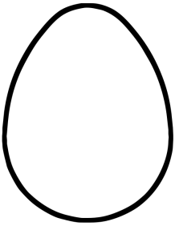MATERIALS:

* A PAPER EGG
* COLOURED PAPER

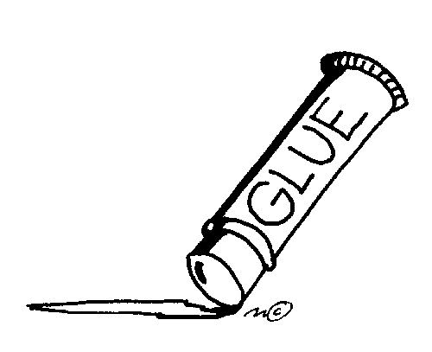

* GLUE STICK

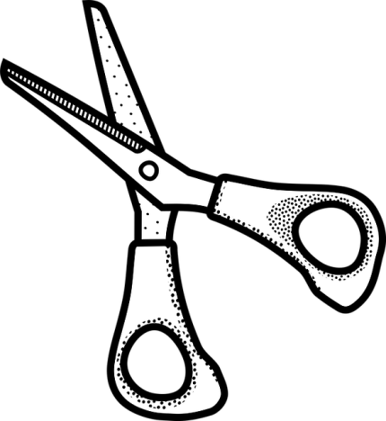

* SCISSORS